CASE STUDY - TRANSPORTATION

Levi D. Smith

November 29, 2006

Advanced Engineering Economy
IE 518 Fall 2006
University of Tennessee, Knoxville
Professor Gregory Sedrick
1. Objective Statement

The objective of this economic analysis is to determine the best transportation system for myself (Levi Smith) over the next 15 years. The transportation must allow me to commute from my house to work four days a week, to the Knoxville UT Campus two days a week, and to Atlanta, GA at least 12 times a year at the highest benefit to cost ratio.

2. Assumptions and Constraints
My work location is 2.9 miles away from my house. The UT Knoxville Campus is 24.3 miles away from my house. Atlanta, GA is 218 from my house. Therefore, the vehicle will need to provide transportation for (2.9 * 4 * 52) + (24.3 * 2 * 52) + (218 * 12) = 5,746.4 miles per year. Overall, the vehicle must provide 86,196 miles of transportation over 15 years.

The analysis will assume that the interest rate is 10%.

The maintenance cost of the vehicles is assumed to remain constant over the 15 year period.

The salvage values of vehicles are based on the blue book trade in value of 1991 models (2006 - 15 = 1991).

The cost of replacing vehicles must not exceed $3,000.

3. Alternatives
1) Keep my current 2006 Ford Ranger truck

2) Buy a new 2007 Toyota Camry hybrid vehicle

3) Buy a new electric Tiger Truck

4) Rent a 2006 Nissan Sentra

4. Develop Costs and Benefits
Benefits
Safety
Engine
Visual Appeal
Ease to Park
Storage Capacity / Passengers
Pollution Emission / Exhaust

Costs
Purchase Price
Gas Cost
Rental Cost
Tire Replacement
Brake Replacement
Oil Change
Tune Up
Rental Cost
Electricity Cost to Charge Vehicle
Trade-In of Current Vehicle (Negative Cost)
Salvage Value after 15 years (Negative Cost)

5. Evaluate Alternatives

Benefit Ranking

Benefit | Rank | Importance Rating
Safety | 1 | 0.267
Engine | 2 | 0.233
Visual Appeal | 3 | 0.233
Ease to Park | 4 | 0.133
Storage Capacity / Passengers | 5 | 0.100
Pollution Emission / Exhaust | 6 | 0.033

Initial Rankings and Totals

 | Ford Ranger | Toyota Camry | Tiger Truck | Nissan Sentra
Safety Rating | 2 | 4 | 1 | 1
Engine Type | 4 | 2 | 1 | 2
Visual Appeal | 3 | 2 | 1 | 2
Ease to Park | 2 | 3 | 4 | 3
Storage Capacity / Passengers | 2 | 4 | 1 | 4
Pollution Emission / Exhaust | 2 | 3 | 4 | 3
Total | 15 | 18 | 12 | 15

Rankings and Totals with Importance Rating applied

 | Importance Rating | Ford Ranger | Toyota Camry | Tiger Truck | Nissan Sentra
Safety Rating | 0.267 | 0.534 | 1.068 | 0.267 | 0.267
Engine Type | 0.233 | 0.932 | 0.466 | 0.233 | 0.466
Visual Appeal | 0.233 | 0.699 | 0.466 | 0.233 | 0.466
Ease to Park | 0.133 | 0.266 | 0.399 | 0.532 | 0.399
Storage Capacity / Passengers | 0.100 | 0.2 | 0.4 | 0.1 | 0.4
Pollution Emission / Exhaust | 0.033 | 0.066 | 0.099 | 0.132 | 0.099
Total |  | 2.697 | 2.898 | 1.497 | 2.097

Costs
1) Keep 2006 Ford Ranger
Gas Mileage: 19 mpg
Purchase Price: $0 (already own it)
Gas Cost for Current Year: 5,746.4 miles / 19 mpg * $2.04 = $616.98
Tire Replacement: $250 every 2 years
Oil Change: $100 per year
Break Replacement: $200 every 2 years
Tune-Up: $150 every 2 years
Trade-In: $0
Salvage Value: $1,230
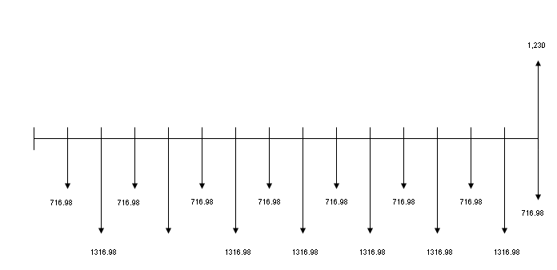
Below is the calculation of total present worth for the 2006 Ford Ranger alternative.

i | (P/F, 0.1, i) | Cash Flow | PW | Total PW
0 | 1 | 0 | 0 | -7263.57
1 | 0.9091 | -716.98 | -651.807
2 | 0.8264 | -1316.98 | -1088.35
3 | 0.7513 | -716.98 | -538.667
4 | 0.683 | -1316.98 | -899.497
5 | 0.6209 | -716.98 | -445.173
6 | 0.5645 | -1316.98 | -743.435
7 | 0.5132 | -716.98 | -367.954
8 | 0.4665 | -1316.98 | -614.371
9 | 0.4241 | -716.98 | -304.071
10 | 0.3855 | -1316.98 | -507.696
11 | 0.3505 | -716.98 | -251.301
12 | 0.3186 | -1316.98 | -419.59
13 | 0.2897 | -716.98 | -207.709
14 | 0.2633 | -1316.98 | -346.761
15 | 0.2394 | 513.02 | 122.817
2) Buy 2007 Toyota Camry Hybrid
Gas Mileage: 39 mpg
Purchase Price: $26,200
Gas Cost for Current Year: 5,746.4 miles / 39 mpg * $2.04 = $300.58
Tire Replacement: $250 every 2 years
Oil Change: $100 per year
Break Replacement: $200 every 2 years
Tune-Up: $150 every 2 years
Trade-In: - $14,800
Salvage Value: $1,550

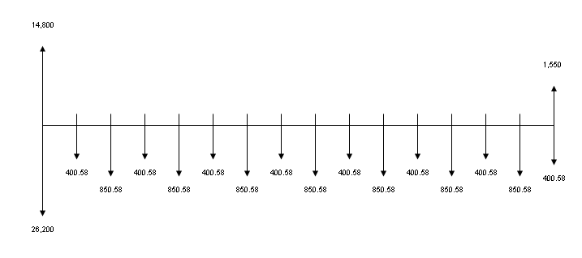
Below is the calculation of total present worth for the 2007 Toyota Camry Hybrid alternative.

i | (P/F, 0.1, i) | Cash Flow | PW | Total PW
0 | 1 | -11400 | -11400 | -15654.3
1 | 0.9091 | -400.58 | -364.167
2 | 0.8264 | -850.58 | -702.919
3 | 0.7513 | -400.58 | -300.956
4 | 0.683 | -850.58 | -580.946
5 | 0.6209 | -400.58 | -248.72
6 | 0.5645 | -850.58 | -480.152
7 | 0.5132 | -400.58 | -205.578
8 | 0.4665 | -850.58 | -396.796
9 | 0.4241 | -400.58 | -169.886
10 | 0.3855 | -850.58 | -327.899
11 | 0.3505 | -400.58 | -140.403
12 | 0.3186 | -850.58 | -270.995
13 | 0.2897 | -400.58 | -116.048
14 | 0.2633 | -850.58 | -223.958
15 | 0.2394 | 1149.42 | 275.1711
3) Buy Electric Tiger Truck
Gas Mileage: N/A
Purchase Price: $11,925
Gas Cost for Current Year: $0 (does not use gas)
Tire Replacement: $250 every 2 years
Oil Change: $0
Break Replacement: $200 every 2 years
Tune-Up: $150 every 2 years
Electricity Cost to Charge Vehicle: Negligible
Trade-In: - $14,800
Salvage Value: $500 (estimate)

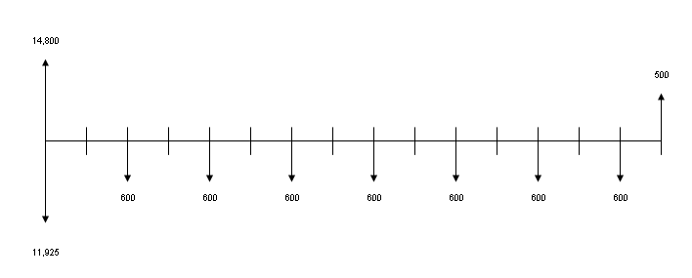
Below is the calculation of total present worth for the Electric Tiger Truck alternative.

i | (P/F, 0.1, i) | Cash Flow | PW | Total PW
0 | 1 | 2875 | 2875 | 770.32
1 | 0.9091 | 0 | 0
2 | 0.8264 | -600 | -495.84
3 | 0.7513 | 0 | 0
4 | 0.683 | -600 | -409.8
5 | 0.6209 | 0 | 0
6 | 0.5645 | -600 | -338.7
7 | 0.5132 | 0 | 0
8 | 0.4665 | -600 | -279.9
9 | 0.4241 | 0 | 0
10 | 0.3855 | -600 | -231.3
11 | 0.3505 | 0 | 0
12 | 0.3186 | -600 | -191.16
13 | 0.2897 | 0 | 0
14 | 0.2633 | -600 | -157.98
15 | 0.2394 | 0 | 0
4) Rent 2006 Nissan Sentra
Gas Mileage: 31 mpg
Purchase Price: $0 (renting it)
Gas Cost for Current Year: 5,746.4 miles / 31 mpg * $2.04 = $378.15
Tire Replacement: $0
Oil Change: $0
Break Replacement: $0
Tune-Up: $0
Trade-In: - $14,800
Rental Costs: ($15 per day * 365days) = $5,475 per year
Salvage Value: $0
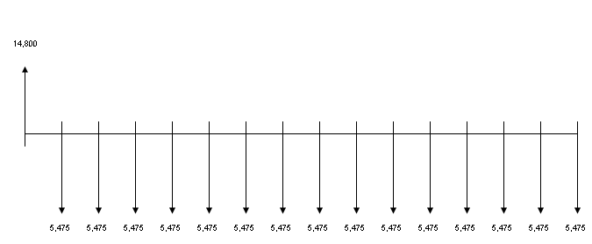

i | (P/F, 0.1, i) | Cash Flow | PW | Total PW
0 | 1 | 14800 | 14800 | -26842.9
1 | 0.9091 | -5475 | -4977.32
2 | 0.8264 | -5475 | -4524.54
3 | 0.7513 | -5475 | -4113.37
4 | 0.683 | -5475 | -3739.43
5 | 0.6209 | -5475 | -3399.43
6 | 0.5645 | -5475 | -3090.64
7 | 0.5132 | -5475 | -2809.77
8 | 0.4665 | -5475 | -2554.09
9 | 0.4241 | -5475 | -2321.95
10 | 0.3855 | -5475 | -2110.61
11 | 0.3505 | -5475 | -1918.99
12 | 0.3186 | -5475 | -1744.34
13 | 0.2897 | -5475 | -1586.11
14 | 0.2633 | -5475 | -1441.57
15 | 0.2394 | -5475 | -1310.72

Benefit to Cost Ratios:

Alternative | Benefit | Cost | B/C Ratio
2006 Ford Ranger | 2.697 | -7,263.57 | -0.0003713
2007 Toyota Camry Hybrid | 2.898 | -15,654.30 | -0.0001851
Electric Tiger Truck | 1.497 | 770.32 | 0.0019433
Rent Nissan Sentra | 2.097 | -26,842.90 | -0.0000781

Sensitivity Analysis
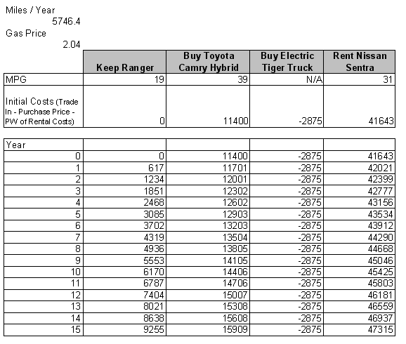

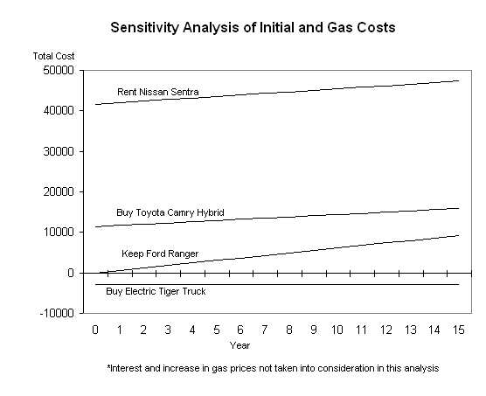

6. Select Alternative

According to the benefit to cost ratio and sensitivity analysis, the Electric Tiger Truck should be purchased to provide transportation for the next 15 years.

7. Evaluate Uncertainties

An evaluation should be performed on the Electric Tiger Truck to determine if it will continue to operate for 15 years without breaking down or needing replacement. Additionally, the durability of the Electric Tiger Truck needs to be tested to determine if it will operate for 86,196 miles without problems. The durability of the electric battery of the Tiger Truck should also be tested, and the cost of replacing the battery should be determined. Laws and ordinances must be checked to ensure that the Electric Tiger Truck is not prohibited on highways and interstate roads.

8. Recommendation

Purchase the Electronic Tiger Truck to provide transportation for the next 15 years, and trade in the current 2006 Ford Ranger.
9. Sources

Google Maps - http://www.google.com/maps
Distances from my house to work, UT Campus, and Atlanta
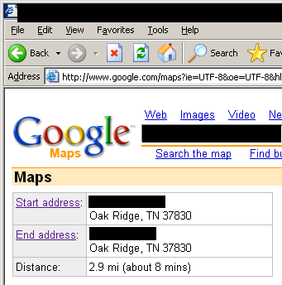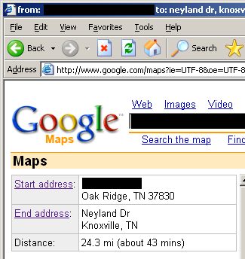

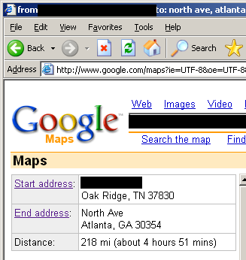

Knoxville Gas Prices - http://www.knoxvillegasprices.com/
Current gas price in Knoxville, TN

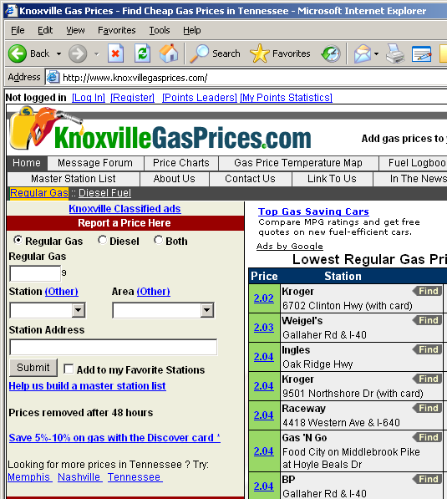

Tiger Truck - http://www.tigertruck.com/electric/truck/index.html
Information on electric Tiger Trucks (cost)
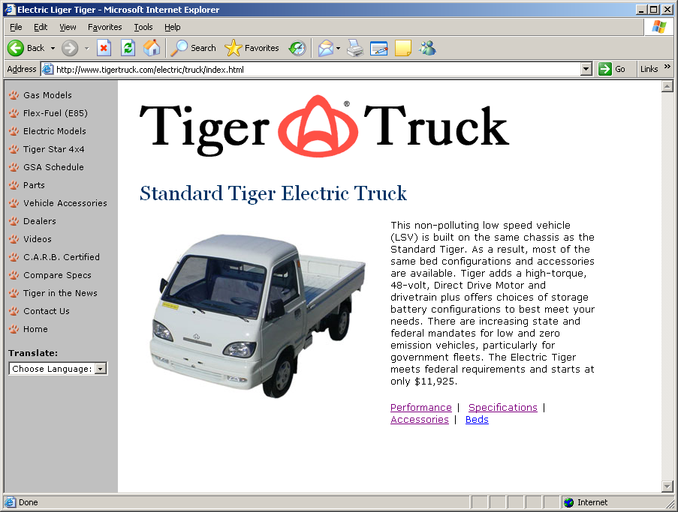

Kelley Blue Book - www.kbb.com
Trade in price of 2006 Ford Ranger 2D Super Cab; V6 4.0L; Automatic; 15,000 miles; XLT
Salvage Values of vehicles
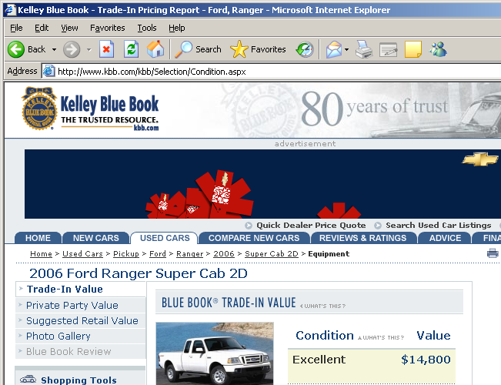

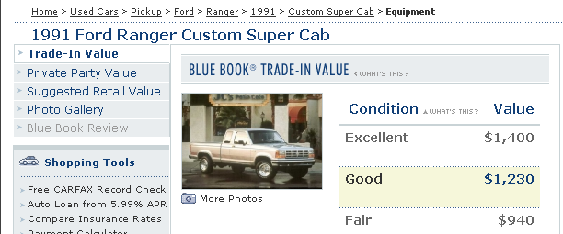

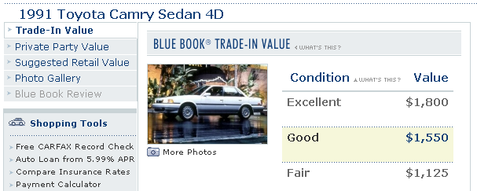

Hertz of Oak Ridge, TN
Nissan Sentra rental information (costs)

Fuel Economy.gov
Gas mileage of vehicles

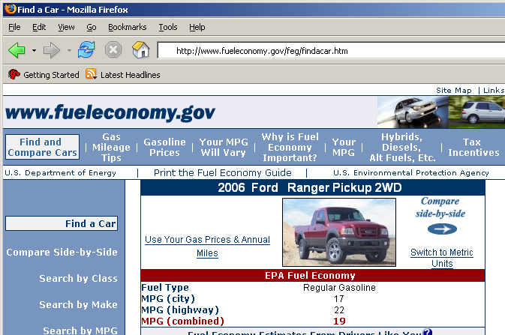

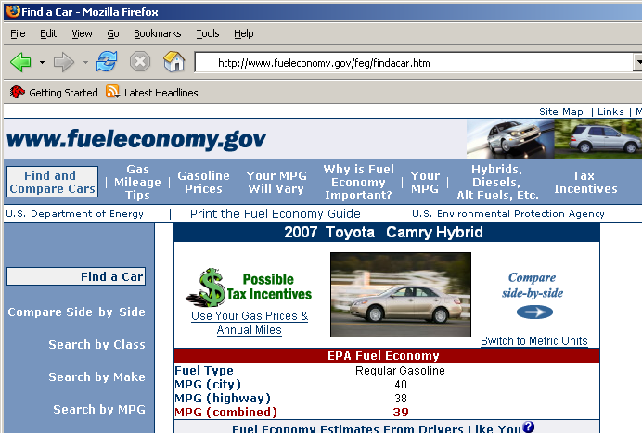
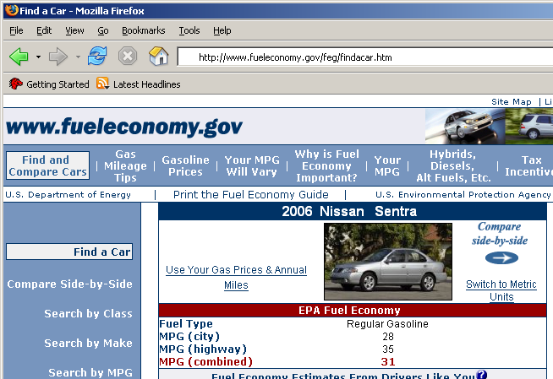

Toyota.com - http://www.toyota.com/vehicles/2007/camry/models.html
Price of 2007 Toyota Camry Hybrid


